Raaziq Whyte

Calendly Assignment

7/13/2020

* Input field allows text when it should only allow numbers
  + Navigate to : <https://codepen.io/CalendlyQA/pen/KKPQLmV>
  + Input text : “Five”
  + Press Play

**Expected results**: That text will not be allowed in the input box.

**Actual results**: User is allowed to enter text.

* When “the last player to go wins the end game message displays the incorrect winner.
  + Navigate to : <https://codepen.io/CalendlyQA/pen/KKPQLmV>
  + Input the number “3” in the text field
  + Press Play
  + Win as “X”

**Expected result**: The message displays “Congratulations Player X ! You’ve won.

Refresh to play again!”

**Actual results**: The message displays “Congratulations Player O ! You’ve won.

Refresh to play again!”.

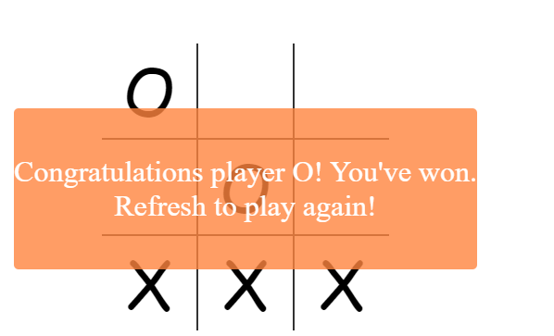

* Play button can be pressed multiple times causing the multiple fields to be generated
  + Navigate to : <https://codepen.io/CalendlyQA/pen/KKPQLmV>
  + Input the number “4” in the text field
  + Press the play button twice

**Expected results**: The Play button is disabled upon generating the game

**Actual results**: The Play button can be repeatedly pressed generating multiple fields. Even after the game has been completed the user is still able to generate fields.

* User is able to continue the game when game over screen displays
  + Navigate to : <https://codepen.io/CalendlyQA/pen/KKPQLmV>
  + Input the number “3” in the text field
  + Press Play
  + Win as “X” or “O”

**Expected Results**: The user is no longer able to play in squares that are behind the game over screen.

**Actual result**: The user is able to continue playing after the game over screen is displayed.



